Part3. CAN command description
Note: Please set the CAN ID first.(default:01)
The default CAN ID for the following chapters is 01.

Read status parameter command
- command1 : 01 30 CRC
read the encoder value(carry).
Downlink frame(PC → SERVO42E/57E)
CAN ID | … | DLC | byte1 | byte2
01 | … | 2 | 30 | CRC(31)

Uplink frame（PC ← SERVO42E/57E）
CAN ID | … | DLC | byte1 | byte2…byte5 | byte6 | byte7 | byte8
01 | … | 8 | code | carry | value |  | Check
01 | … | 8 | 30 | carry(int32_t) | value(uint16_t) |  | CRC

carry: the carry vaule of the encoder.
value: the current vaule of the encoder.(range 0~0x3FFF) When value is greater than 0x3FFF, carry +=1.
When Value is less than 0, carry -=1. For example:
If the current carry|value is 0x3FF0, After one turn CCW,the carry|value (+0x4000) is 0x13FF0.
If the current carry|value is 0x3FF0, After one turn CW,the carry|value (- 0x4000)is 0xFFFFFFFF3FF0.

The Cangaroo example is as follows:
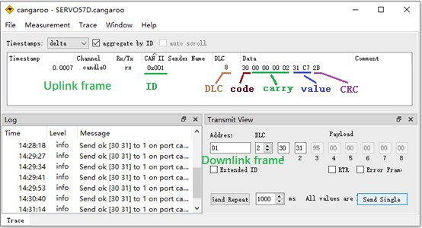

- command2 : 01 31 CRC
read the encoder value(addition).
Downlink frame(PC → SERVO42E/57E)
CAN ID | … | DLC | byte1 | byte2
01 | … | 2 | 31 | CRC(32)

Uplink frame（PC ← SERVO42E/57E）
CAN ID | … | DLC | byte1 | byte2…byte7 | byte8
01 | … | 8 | code | value | Check
01 | … | 8 | 31 | value(int48_t) | CRC

After one turn clockwise,the value += 0x4000; After one turn CCW,the value -= 0x4000;

For example:
If the current value is 0x3FF0, After one turn CCW,the value(+0x4000) is 0x7FF0.
If the current value is 0x3FF0, After one turn CW,the value(-0x4000) is
0xFFFFFFFFFFF0.

- Command3 : 01 32 CRC
Read the real-time speed of the motor.(RPM)
Downlink frame(PC → SERVO42E/57E)
CAN ID | … | DLC | byte1 | byte2
01 | … | 2 | 32 | CRC(33)

Uplink frame（PC ← SERVO42E/57E）
CAN ID | … | DLC | byte1 | byte2…byte3 | byte4
01 | … | 4 | code | data | Check
01 | … | 4 | 32 | speed(int16_t) | CRC
Note : if it run CCW,the speed > 0 (RPM) if it run CW,the speed < 0 (RPM)

- Command4 : 01 33 CRC
Read the number of pulses received.
Downlink frame(PC → SERVO42E/57E)
CAN ID | … | DLC | byte1 | byte2
01 | … | 2 | 33 | CRC(34)

Uplink frame（PC ← SERVO42E/57E）
CAN ID | … | DLC | byte1 | byte2…byte5 | byte6
01 | … | 6 | code | data | Check
01 | … | 6 | 33 | pulses(int32_t) | CRC

- Command5 : 01 34 CRC
read the IO Ports status.
Downlink frame(PC → SERVO42E/57E)
CAN ID | … | DLC | byte1 | byte2
01 | … | 2 | 34 | CRC(3B)

Uplink frame（PC ← SERVO42E/57E）
CAN ID | … | DLC | byte1 | byte2 | byte3
01 | … | 3 | code | data | Check
01 | … | 3 | 34 | status(uint8_t) | CRC

status
bit7 | bit6 | bit5 | bit4 | bit3 | bit2 | bit1 | bit0
reserved |  |  |  | ALM | PEND | IN_2 | IN_1

PEND | 1: | Already in place | 0: | Not in place
ALM | 1: | No alarm | 0: | Alarmed
Note: 42E does not have IN_2 port, bit1 corresponds to En port status.

- Command7 : 01 39 CRC
read the error of the motor shaft angle.
Downlink frame(PC → SERVO42E/57E)
CAN ID | … | DLC | byte1 | byte2
01 | … | 2 | 39 | CRC(3A)

Uplink frame（PC ← SERVO42E/57E）
CAN ID | … | DLC | byte1 | byte2…byte5 | Byte6
01 | … | 6 | code | data | Check
01 | … | 6 | 39 | error(int32_t) | CRC
The error is the difference between the angle you want to control minus the real-time angle of the motor, 0~51200 corresponds to 0~360°.
for example, when the angle error is 1°, the return error is 51200/360= 142.222, and so on.

- Command8 : 01 3A CRC read the En pins status.
Downlink frame(PC → SERVO42E/57E)
CAN ID | … | DLC | byte1 | byte2
01 | … | 2 | 3A | CRC(3B)

Uplink frame（PC ← SERVO42E/57E）
CAN ID | … | DLC | byte1 | byte2 | byte3
01 | … | 3 | code | data | Check
01 | … | 3 | 3A | enable(uint8_t) | CRC
enable =1 Enabled
enable =0 Disabled

- Command10 : 01 3D CRC
Release the motor shaft locked-rotor protection state.

Downlink frame(PC → SERVO42E/57E)
CAN ID | … | DLC | byte1 | byte2
01 | … | 2 | 3D | CRC(3E)

Uplink frame（PC ← SERVO42E/57E）
CAN ID | … | DLC | byte1 | byte2 | byte3
01 | … | 3 | code | data | Check
01 | … | 3 | 3D | status(uint8_t) | CRC
status =1 release success. status =0 release fail.

- Command11 : FA 01 3E CRC
Read the motor shaft protection state.

Downlink frame(PC → SERVO42E/57E)
CAN ID | … | DLC | byte1 | byte2
01 | … | 2 | 3E | CRC(3F)

Uplink frame（PC ← SERVO42E/57E）
CAN ID | … | DLC | byte1 | byte2 | byte3
01 | … | 3 | code | data | Check
01 | … | 3 | 3E | status(uint8_t) | CRC
status =1 protected. status =0 no protected.

Set system parameters command
- Calibrate the encoder

Downlink frame(PC → SERVO42E/57E)
CAN ID | … | DLC | byte1 | byte2 | byte3
01 | … | 3 | 80 | 00 | CRC(81)

Uplink frame（PC ← SERVO42E/57E）
CAN ID | … | DLC | byte1 | byte2 | byte3
01 | … | 3 | code | data | Check
01 | … | 3 | 80 | status(uint8_t) | CRC
status =0 Calibrating…. status =1 Calibrated success. status =2 Calibrating fail.
Note: The calibration only determines the relationship between the motor direction and the encoder, that is, when the motor rotates clockwise, the encoder value increases or decreases. If the motor phase line is wired according to the factory default connection, no calibration is required.

- Set the work mode

Downlink frame(PC → SERVO42E/57E)
CAN ID | … | DLC | byte1 | byte2 | byte3
01 | … | 3 | code | data | Check
01 | … | 3 | 82 | mode | CRC
mode = X0 Pulse+Pulse Open-loop mode (X=0 with encoder X=1 without encoder)
mode = X1 Pulse+Direction Open-loop mode (X=0 with encoder X=1 without encoder)
mode = 02 Pulse+Pulse Closed-loop mode
mode = 03 Pulse+Direction Closed-loop mode (default)
mode = X4 RS485 bus Open-loop mode (X=0 with encoder X=1 without encoder)
mode = 05 RS485 bus Closed-loop mode
Note 1: Pulse control mode, maximum input frequency 300KHz Bus control mode, maximum speed 3000RPM
Note 2: X=0 has encoder, that is, the motor shaft has a magnet, the driver board is installed at the back, and the encoder value can be read X=1 has no encoder, that is, the motor shaft has no magnet, the driver board can be installed arbitrarily, and the encoder value cannot be read

Uplink frame（PC ← SERVO42D/57D）
CAN ID | … | DLC | byte1 | byte2 | byte3
01 | … | 3 | code | data | Check
01 | … | 3 | 82 | status(uint8_t) | CRC
status =1 Set success. status =0 Set fail.

- Set the working current

Downlink frame(PC → SERVO42E/57E)
CAN ID | … | DLC | byte1 | byte2-3 | Byte4
01 | … | 4 | code | data | Check
01 | … | 4 | 83 | ma (uint16_t) | CRC
SERVO42E: Maximum Current =3000mA (default 1600mA) SERVO57E: Maximum Current =5200mA (default 3200mA)

Uplink frame（PC ← SERVO42E/57E）
CAN ID | … | DLC | byte1 | byte2 | byte3
01 | … | 3 | code | data | Check
01 | … | 3 | 83 | status(uint8_t) | CRC
status =1 Set success. status =0 Set fail.

- Set subdivision(Default 16 subdivisions)

Downlink frame(PC → SERVO42D/57D)
CAN ID | … | DLC | byte1 | byte2 | byte3
01 | … | 3 | code | data | Check
01 | … | 3 | 84 | micstep(00~FF) | CRC
Note1:The value range of micstep (decimal) is as follows: 0，2，4，8，16，32，64，128，
5，10，20，25，40，50，100，200
Note2:0 corresponds to 256 subdivisions

Uplink frame（PC ← SERVO42D/57D）
CAN ID | … | DLC | byte1 | byte2 | byte3
01 | … | 3 | code | data | Check
01 | … | 3 | 84 | status(uint8_t) | CRC
status =1 Set success. status =0 Set fail.

- Set the active of the En pin

Downlink frame(PC → SERVO42E/57E)
CAN ID | … | DLC | byte1 | byte2 | byte3
01 | … | 3 | code | data | Check
01 | … | 3 | 85 | enable(00~02) | CRC
enable = 00 active low (L) (default) enable = 01 active high (H)
enable = 02 active always (Hold)
Uplink frame（PC ← SERVO42E/57E）
CAN ID | … | DLC | byte1 | byte2 | byte3
01 | … | 3 | code | data | Check
01 | … | 3 | 85 | status(uint8_t) | CRC
status =1 Set success. status =0 Set fail.
Note1:After successful setting, it will take 100ms to receive the pulse signal.
Note2:Only valid for pulse control mode.

- Set the direction of motor rotation

Downlink frame(PC → SERVO42E/57E)
CAN ID | … | DLC | byte1 | byte2 | byte3
01 | … | 3 | code | data | Check
01 | … | 3 | 86 | dir(00~01) | CRC
dir = 00 CW (default) dir = 01 CCW

Uplink frame（PC ← SERVO42E/57E）
CAN ID | … | DLC | byte1 | byte2 | byte3
01 | … | 3 | code | data | Check
01 | … | 3 | 86 | status(uint8_t) | CRC
status =1 Set success. status =0 Set fail.

Note: This instruction can also change the bus mode to control the running direction of the motor.

- Set pulse delay

Downlink frame(PC → SERVO42E/57E)
CAN ID | … | DLC | byte1 | byte2 | byte3
01 | … | 3 | code | data | Check
01 | … | 3 | 87 | delay(uint8_t) | CRC

delay = 00 | 0ms | delay = 01 | 4ms
delay = 02 | 20ms(default value) | delay = 03 | 40ms

Uplink frame（PC ← SERVO42E/57E）
CAN ID | … | DLC | byte1 | byte2 | byte3
01 | … | 3 | code | data | Check
01 | … | 3 | 87 | status(uint8_t) | CRC
status =1 Set success. status =0 Set fail.

- Set the motor shaft locked-rotor protection function

Downlink frame(PC → SERVO42E/57E)
CAN ID | … | DLC | byte1 | byte2 | byte3
01 | … | 3 | code | data | Check
01 | … | 3 | 88 | enable(00~01) | CRC
enable = 01 enabled protection (default) enable = 00 disabled protection

Uplink frame（PC ← SERVO42E/57E）
CAN ID | … | DLC | byte1 | byte2 | byte3
01 | … | 3 | code | data | Check
01 | … | 3 | 88 | status(uint8_t) | CRC
status =1 Set success. status =0 Set fail.

Note: After the stall protection, the stall protection state can be released through the enable signal , serial port command,Command (3D) mode or EN level invalid mode.

- Set the Stalling tolerant value

Downlink frame(PC → SERVO42E/57E)
CAN ID | … | DLC | byte1 | byte2-3 | Byte4
01 | … | 3 | code | data | Check
01 | … | 3 | 89 | value（0-  0x7FFF） | CRC
The default value is 0x64.
When the error exceeds the value, the stall protection is triggered and the motor loosens its shaft.
value = 0x64 corresponds to an angle of 180 degrees value = 0xC8 corresponds to an angle of 360 degrees and so on...

Uplink frame（PC ← SERVO42E/57E）
CAN ID | … | DLC | byte1 | byte2 | byte3
01 | … | 3 | code | data | Check
01 | … | 3 | 89 | status(uint8_t) | CRC
status =1 Set success. status =0 Set fail.

- Set the CAN bitRate

Downlink frame(PC → SERVO42E/57E)
CAN ID | … | DLC | byte1 | byte2 | byte3
01 | … | 3 | code | data | Check
01 | … | 3 | 8A | bitRate (00~03) | CRC
bitRate = 00 125K bitRate = 01 250K
bitRate = 02 500K (default) bitRate = 03 1M

Uplink frame（PC ← SERVO42E/57E）
CAN ID | … | DLC | byte1 | byte2 | byte3
01 | … | 3 | code | data | Check
01 | … | 3 | 8A | status(uint8_t) | CRC
status =1 Set success. status =0 Set fail.

- Set the CAN ID

Downlink frame(PC → SERVO42E/57E)
CAN ID | … | DLC | byte1 | byte2 | byte3 | byte4
01 | … | 4 | code | data |  | Check
01 | … | 4 | 8B | ID(00~7FF) |  | CRC
Note1: the default ID is 01
Note2: 00 is the broadcast address

Uplink frame（PC ← SERVO42E/57E）
CAN ID | … | DLC | byte1 | byte2 | byte3
01 | … | 3 | code | data | Check
01 | … | 3 | 8B | status(uint8_t) | CRC
status =1 Set success. status =0 Set fail.

- Set the slave respond and active

Downlink frame(PC → SERVO42E/57E)
CAN ID | … | DLC | byte1 | byte2 | byte3 | byte4
01 | … | 4 | code | data | data | Check
01 | … | 4 | 8C | respon(00~01) | active(00-01) | CRC
respon = 01 enabled respond (default) respon = 00 disabled respond
active = 01 enabled active (default) active = 00 disabled active

Note: If disable respond, It can query the running status of the
motor by command “F1”.

Uplink frame（PC ← SERVO42E/57E）
CAN ID | … | DLC | byte1 | byte2 | byte3
01 | … | 3 | code | data | Check
01 | … | 3 | 8C | status(uint8_t) | CRC
status =1 Set success. status =0 Set fail.

The difference between respond and active Take position control mode 1 as an example:
Host sends 01 FD 02 80 02 00 FA 00 7C
  - In no response mode (respon =0, active = xx) The slave does not return any information.
  - In the mode of not actively initiating data (respon =1, active =0) Slave returns immediately Position control starts 01 or fails 00.
  - In default mode (respon =1, active =1)
Slave returns immediately Position control starts 01 or fails 00. Return to 02 or 03 after the motor finishes running or touches the limit stop.

- Set whether to lock the axis when starting bus mode

Downlink frame(PC → SERVO42E/57E)
CAN ID | … | DLC | byte1 | byte2 | byte3
01 | … | 3 | code | data | Check
01 | … | 3 | 8F | enable(00~01) | CRC
enable = 01 lock the axis(default value) enable = 00 unlock axis

Uplink frame（PC ← SERVO42E/57E）
CAN ID | … | DLC | byte1 | byte2 | byte3
01 | … | 3 | code | data | Check
01 | … | 3 | 8F | status(uint8_t) | CRC
status =1 Set success. status =0 Set fail.

- Set the group ID

Downlink frame(PC → SERVO42E/57E)
CAN ID | … | DLC | byte1 | byte2 | byte3 | byte4
01 | … | 4 | code | data |  | Check
01 | … | 4 | 8D | ID(01~0x7FF) |  | CRC

Uplink frame（PC ← SERVO42E/57E）
CAN ID | … | DLC | byte1 | byte2 | byte3
01 | … | 3 | code | data | Check
01 | … | 3 | 8D | status(uint8_t) | CRC
status =1 Set success. status =0 Set fail.

For example, there are 6 motors with the settings ID:
 | Broadcast ID | Slave ID | Group ID
motor 1 | 0 | 1 | 0x50
motor 2 | 0 | 2 | 0x50
motor 3 | 0 | 3 | 0x50
motor 4 | 0 | 4 | 0x51
motor 5 | 0 | 5 | 0x51
motor 6 | 0 | 6 | 0x51

send | 01 | FD | 01 | 2C | 64 | 00 | 0C | 80 | 1B, | motor 1 | will | rotate | a | turn
send | 00 | FD | 01 | 2C | 64 | 00 | 0C | 80 | 1A, | motor1-6 | will | rotate | a | turn
send | 50 | FD | 01 | 2C | 64 | 00 | 0C | 80 | 6A, | motor1-3 | will | rotate | a | turn
send | 51 | FD | 01 | 2C | 64 | 00 | 0C | 80 | 6B, | motor4-6 | will | rotate | a | turn
Note: Slave does not answer if group address is used.

Write IO port command

Downlink frame(PC → SERVO42E/57E)
CAN  ID | … | DLC | byte1 | Byte2 |  |  |  |  |  |  |  | Byte3
01 | … | 3 | code | bit7 | bit6 | bit5 | bit4 | bit3 | bit2 | bit1 | bit0 | Check
01 | … | 3 | 36 | alm_mask |  | pend_mask |  | ALM | PEND | 0 |  | CRC
alm_mask 0: Do not write to ALM IO port (ALM default alarm signal)
1: Write the ALM value to the ALM IO port 2: ALM IO port value remains unchanged
pend_mask 0: Do not write to the PEND IO port (PEND defaults to the in-place signal)
1: Write the PEND value to the PEND IO port 2: The PEND IO port value remains unchanged
ALM ALM port write value (0/1) PEND PEND port write value (0/1)

Uplink frame（PC ← SERVO42E/57E）
CAN ID | … | DLC | byte1 | byte2 | byte3
01 | … | 3 | code | data | Check
01 | … | 3 | 36 | status(uint8_t) | CRC
status =1 write success. status =0 write fail.

Set Home command
- Set the parameter of home

Downlink frame(PC → SERVO42E/57E)
CAN ID | … | DL  C | byte1 | byte2 | byte3 | byte4-5 | Byte6 | Byte7 | Byte8
01 | … | 8 | code | level | dir | speed | enable | hmM  ode | Chec  k
01 | … | 8 | 90 | homeTrig | homeDir | homeSpeed | EndLimit | mode | CRC
HmTrig the effective level of the end stop
0：Low (default value) 1：High
HmDir the direction of go home
0： CW(default value) 1：CCW
HmSpeed the speed of go home
0~3000 (RPM) default value = 60 EndLimit
0: disable endstop-limit(default value) 1: enable endstop-limit
Note : The speed description can be found in Chapter 6.1.

Uplink frame（PC ← SERVO42E/57E）
CAN ID | … | DLC | byte1 | byte2 | byte3
01 | … | 3 | code | data | Check
01 | … | 3 | 90 | status(uint8_t) | CRC
status =1 set success. status =0 set fail.
Note1:When EndLimit = 1, in bus control mode, the left limit is triggered and the motor no longer runs to the left; the right limit is triggered and the motor no longer runs to the right;
Note2: When using the limit function for the first time or changing the limit parameters, it is necessary to execute a limit reset ("91" command).
Note3:The limit function is invalid in pulse control mode.

- Go home

Downlink frame(PC → SERVO42E/57E)
CAN ID | … | DLC | byte1 | byte2
01 | … | 2 | 91 | CRC(92)
Note: When returning to zero with limit, if the limit switch is already in the closed state, the motor will rotate a certain distance in the opposite direction of homeDir (set by command 94) and then return to zero.

Uplink frame（PC ← SERVO42E/57E）
CAN ID | … | DLC | byte1 | byte2 | byte3
01 | … | 3 | code | data | Check
01 | … | 3 | 91 | status(uint8_t) | CRC
status =0 go home fail. status =1 go home start. status =2 go home sucess.

- Set Currnet Axis to zero
It can set the current Axis to Zero. Just as “GoHome”without
run the motor.
Downlink frame(PC → SERVO42E/57E)
CAN ID | … | DLC | byte1 | byte2
01 | … | 2 | 92 | CRC(93)

Uplink frame（PC ← SERVO42E/57E）
CAN ID | … | DLC | byte1 | byte2 | byte3
01 | … | 3 | code | data | Check
01 | … | 3 | 92 | status(uint8_t) | CRC
status =0 set fail. status =1 set success.

- Set the unlimited switch to return to zero current

Uplink frame（PC ← SERVO42E/57E）
CAN ID | … | DLC | byte1 | byte2-3 | Byte4
01 | … | 3 | code | data | Check
01 | … | 3 | 93 | status(uint8_t) | CRC

SERVO42E maximum return to zero current 3000mA (default 300mA) SERVO57E maximum return to zero current 5200mA (default 600mA)

Uplink frame（PC ← SERVO42E/57E）
CAN ID | … | DLC | byte1 | byte2 | byte3
01 | … | 3 | code | data | Check
01 | … | 3 | 93 | status(uint8_t) | CRC
status =0 set fail. status =1 set success.

Note1:When the infinite switch returns to zero, the motor runs at a fixed torque (nullHmMa) until it hits an obstacle and stops, then runs in the reverse direction for a distance (retValue) and stops.
The stop point is the zero point.
Note2:The unlimited return to zero current value is only valid during unlimited return to zero operation. It should be set to a smaller current as much as possible to avoid damaging the motor.

- Set the parameter of “noLimit”go home

Downlink frame(PC → SERVO42D/57D)
CAN ID | … | DLC | byte1 | Byte2-5 | Byte6-7 | Byte8
01 | … | 6 | code | Reverse Angle | Hm_ma | Check
01 | … | 6 | 94 | retValue | ma | CRC

mode 0: used Limit switch for go home(default value).
1: no Limit switch for go home.
trig 0: Disable the zero return trigger function (default value, return to zero through command 91.
1: Automatically return to zero after power on.
2: En signal triggers zero return (valid only in pulse control mode). retValue: 0~0xFFFFFFFF (Default = 0x2000, returns half a turn, 180 degrees) for example：
retValue = 0x4000 （it will return 360 degree）
retValue = 0x2000 （it will return 180 degree）（default）

Uplink frame（PC ← SERVO42D/57D）
CAN ID | … | DLC | byte1 | byte2 | byte3
01 | … | 3 | code | data | Check
01 | … | 3 | 94 | status(uint8_t) | CRC
status =0 set fail. status =1 set success.

Note1: In pulse control mode, when hmTrig = 2, when the En signal line generates a 200ms width non-enable level, the motor is triggered to return to zero. (Pulse recognition range 150ms~250ms).
Note2: When En is low level to enable the motor, a 200ms high level signal is generated to trigger the motor to return to zero.
When En is high level to enable the motor, a 200ms low levelsignal is generated to trigger the motor to return to zero.

- Set limit port remap
Map the En port to the right limit port, which is only suitable for bus control mode.
Downlink frame(PC → SERVO42E/57E)
CAN ID | … | DLC | byte1 | byte2 | byte3
01 | … | 3 | code | data | Check
01 | … | 3 | 9E | reMap (uint8_t) | CRC
reMap = 01 enable remap limit port
reMap = 00 disable remap limit port (default)

Uplink frame（PC ← SERVO42E/57E）
CAN ID | … | DLC | byte1 | byte2 | byte3
01 | … | 3 | code | data | Check
01 | … | 3 | 9E | status(uint8_t) | CRC
status =1 Set success. status =0 Set fail.

Note: This instruction is invalid for 57E and pulse control mode.

Setting the pulse division output command
Map the PEND port as the pulse frequency division output port.

Downlink frame(PC → SERVO42D/57D)
CAN ID | … | DLC | byte1 | Byte2 | Byte3-6 | Byte7
01 | … | 7 | code | Start level | division period | Check
01 | … | 7 | 9F | divLevel | divPeriod | CRC
divLevel 0: Starting level low; 1: Starting level high (default 0) divPeriod division period (default 0)

When divPeriod < 100, there is no frequency division output When divPeriod >= 100, the PEND port flips once for every
divPeriod pulse cycle.
For example, if 16 subdivisions are set and divPeriod = 3200, the PEND port flips once for every motor rotation.
Note: To cancel this function, set divPeriod = 0.

Uplink frame（PC ← SERVO42D/57D）
CAN ID | … | DLC | byte1 | byte2 | byte3
01 | … | 3 | code | data | Check
01 | … | 3 | 9F | status(uint8_t) | CRC
status =0 set fail. status =1 set success.

Restore default parameters and reset and restart instructions
    - Restore default parameters

Downlink frame(PC → SERVO42E/57E)
CAN ID | … | DLC | byte1 | byte2
01 | … | 2 | 3F | CRC(40)

Uplink frame（PC ← SERVO42E/57E）
CAN ID | … | DLC | byte1 | byte2 | byte3
01 | … | 3 | code | data | Check
01 | … | 3 | 3F | status(uint8_t) | CRC
status =1 restore success. status =0 restore fail.

Note: After restored the parameters, It will reboot again.

Restart the motor

Downlink frame(PC → SERVO42E/57E)
CAN ID | … | DLC | byte1 | byte2
01 | … | 2 | 41 | CRC

Uplink frame（PC ← SERVO42E/57E）
CAN ID | … | DLC | byte1 | byte2 | byte3
01 | … | 3 | code | data | Check
01 | … | 3 | 41 | status(uint8_t) | CRC
status =1 restart success. status =0 restart fail.

Note:This command only resets the motor and does not modify the configuration parameters.

Read version information

Downlink frame(PC → SERVO42E/57E)
CAN ID | … | DLC | byte1 | byte2
01 | … | 2 | 40 | CRC

Downlink frame(PC → SERVO42E/57E)
CAN  ID | … | DLC | byte1 | Byte2 |  |  | Byte3-5 | Byte6
01 | … | 6 | code | bit7 | bit5-bit4 | bit3-bit0 |  | Check
01 | … | 6 | 40 | serials | cal | hardVer | firmVer[3] | CRC
series = 1 E series stepper motor series = 0 D series stepper motor
cal = 1 When the motor rotates clockwise, the encoder value increases cal = 2 When the motor rotates clockwise, the encoder value decreases

Firmware version: firmVer[0] = 1 firmVer[1] = 0 firmVer[2] = 0 Corresponding version V1.0.0

The hardware versions correspond to the following
Type | hardVer
S42E_RS485 | 1
S42E_CAN | 2
S57E_RS485 | 3
S57E_CAN | 4
S28E_RS485 | 5
S28E_CAN | 6
S35E_RS485 | 7
S35E_CAN | 8

Read/Write User ID
- Write User ID

Downlink frame(PC → SERVO42E/57E)
CAN ID | … | DLC | byte1 | byte2-5 | Byte6
01 | … | 6 | code | User ID | Check
01 | … | 6 | 42 | ID (uint32_t) | CRC

Uplink frame（PC ← SERVO42E/57E）
CAN ID | … | DLC | byte1 | byte2 | byte3
01 | … | 3 | code | data | Check
01 | … | 3 | 42 | status(uint8_t) | CRC
status =1 Write success. status =0 Write fail.

- Read User ID

Downlink frame(PC → SERVO42E/57E)
CAN ID | … | DLC | byte1 | byte2
01 | … | 2 | 42 | CRC

Uplink frame（PC ← SERVO42E/57E）
CAN ID | … | DLC | byte1 | byte2-5 | Byte6
01 | … | 6 | code | USER ID | Check
01 | … | 6 | 42 | ID(uint32_t) | CRC

Read system Parameter command
The command format for reading system parameters is as follows:
Downlink frame(PC → SERVO42E/57E)
CAN ID | … | DLC | byte1 | byte2 | byte 3
01 | … | 3 | 00 | code | CRC
code : corresponding to the system parameters.
For example, if you want to read the "work mode", the corresponding code is 82H.

The format of the returned parameter data is as follows:
Uplink frame（PC ← SERVO42E/57E）
CAN ID | … | DLC | byte 1 | byte 2-n | byte n+1
01 | … | n+1 | CODE | parameters | Check
01 | … | n+1 | code | param | CRC
param : the system parameters.
Note: The returned param data format just the same as the data format when setting this parameter.

If the parameter does not support reading, the returned data is as follows:
Uplink frame（PC ← SERVO42E/57E）
CAN ID | … | DLC | byte 1 | byte 2 | byte 3 | byte 4
01 | … | 4 | CODE |  |  | Check
01 | … | 4 | code | FFH | FFH | CRC

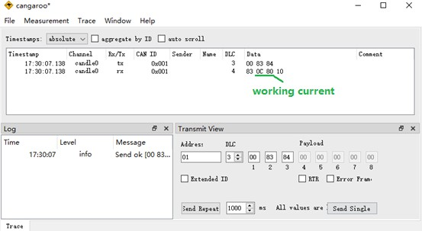
The following figure shows an example of reading "working current":

Part4. Run the motor by CAN command
Note: This chapter needs to set the working mode to serial mode. (SR_OPEN/SR_CLOSE/SR_VFOC)

Description the parameters of speed and acceleration
- speed
The speed parameter ranges from 0 to 3000. The larger the value, the faster the motor rotates.

Note: The speed value is calibrated based on 16/32/64 subdivisions, and the speeds of other subdivisions need to be calculated based on 16 subdivisions.
For example, setting speed=1200
At 8 subdivisions, the speed is 2400 (RPM)
At 16/32/64 subdivisions, the speed is 1200 (RPM) At 128 subdivisions, the speed is 150 (RPM)

- acceleration
The value of the acceleration(acc) ranges from 0 to 255. The larger the value, the faster the motor accelerates/decelerates.
If acc=0, the motor runs without acceleration or deceleration, and runs directly at the set speed.

① accelerates

Suppose at time t1，the current speed is Vt1 (Vt1 < speed) at time t2，the current speed is Vt2
t2 – t1 = （256-acc）* 50 (uS)
The relationship between the current speed Vti, acc, and speed is as follows:
Vt2 = Vt1 + 1 (Vt2 <= speed) For example: acc = 236,speed = 3000
T(ms) | speed（RPM） |  | T(ms) | speed (RPM)
0 | 0 |  | … | …
1 | 1 |  | … | …
2 | 2 |  | 2998 | 2998
3 | 3 |  | 2999 | 2999
… | … |  | 3000 | 3000

② decelerates

Suppose at time t1，the current speed is Vt1 (Vt1 > speed) at time t2，the current speed is Vt2
t2 – t1 = （256-acc）* 50 (uS)
The relationship between the current speed Vti, acc, and speed is as follows:
Vt2 = Vt1 - 1 (Vt2 >= speed)

Query/Enable the motor command
- Query the motor status

Downlink frame(PC → SERVO42E/57E)
CAN ID | … | DLC | byte1 | byte2
01 | … | 2 | F1 | CRC(F2)

Uplink frame（PC ← SERVO42E/57E）
CAN ID | … | DLC | byte1 | byte2 | byte3
01 | … | 3 | code | data | Check
01 | … | 3 | F1 | status(uint8_t) | CRC
status = 0 query fail. status = 1 motor stop status = 2 motor speed up status = 3 motor speed down status = 4 motor full speed status = 5 motor is homing status = 6 motor is Cal…
Note 1: This instruction is only valid in bus control mode. Note 2: This instruction can only query the motor calibration operation in pulse control mode.

- Enable the motor
Note:In bus control mode, the enable state of the driver board is no longer controlled by the level of the En pin, but is controlled by this command.

Downlink frame(PC → SERVO42E/57E)
CAN ID | … | DLC | byte1 | byte2 | byte3
01 | … | 3 | code | data | Check
01 | … | 3 | F3 | en(00~01) | CRC
en = 00 disable. en = 01 enable.

Uplink frame（PC ← SERVO42E/57E）
CAN ID | … | DLC | byte1 | byte2 | byte3
01 | … | 3 | code | data | Check
01 | … | 3 | F3 | status(uint8_t) | CRC
status =1 Set success. status =0 Set fail.

Emergency stop the motor

Downlink frame(PC → SERVO42E/57E)
CAN ID | … | DLC | byte1 | byte2
01 | … | 2 | F7 | CRC

Uplink frame（PC ← SERVO42E/57E）
CAN ID | … | DLC | byte1 | byte2 | byte3
01 | … | 3 | code | data | Check
01 | … | 3 | F7 | status(uint8_t) | CRC
status = 0 stop fail. status = 1 stop success.
Note: If the motor rotating more than 1000RPM, it is not a good idea to stop the motor immediately!

Speed mode command
In speed mode, the motor can be run with a fixed acceleration and speed.

    - Run the motor in speed mode

Downlink frame(PC → SERVO42E/57E)
CAN ID | … | DLC | byte1 | byte 2 |  |  | byte 3 | byte 4 | byte 5
01 | … | 5 | code | dir | Rev | speed |  | acc | Check
01 | … | 5 | F6 | b7 | b6-b4 | b3-b0 | b7-b0 | acc | CRC
 |  |  |  | dir | —— | speed |  | acc | CRC

byte2: The highest bit indicates the direction, the lower 4 bits and byte3 together indicate the speed
byte3: The lower 4 bits of byte2 and byte3 together indicate speed
The parameter description is as follows: dir: the value range is 0/1 (CCW/CW)
speed: the speed, the value range is 0-3000 acc: the acceleration, the value range is 0-255

for example：
Send “01 F6 01 40 02 3A”,
the motor rotates forward at acc=2, speed=320RPM
Send “01 F6 81 40 02 BA”,
the motor reverses at acc=2, speed=320RPM

Uplink frame（PC ← SERVO42E/57E）
CAN ID | … | DLC | byte1 | byte2 | byte3
01 | … | 3 | code | data | Check
01 | … | 3 | F6 | status(uint8_t) | CRC
status = 1 run success. status = 0 run fail.

Note: This instruction is only valid in bus control mode.

    - Stop the motor in speed mode

Downlink frame(PC → SERVO42E/57E)
CAN ID | … | DLC | byte1 | byte 2 |  |  | byte 3 | byte 4 | byte 5
01 | … | 5 | code | dir | Rev | speed |  | acc | Check
01 | … | 5 | F6 | b7 | b6-b4 | b3-b0 | b7-b0 | acc | CRC
 |  |  |  | 0 | 0 | 0 |  | acc | CRC

The stop command can stop the motor slowly, or stop the motor immediately.
When setting acc ≠ 0, the motor decelerates and stops slowly
When setting acc = 0, the motor stops immediately

① Deceleration and stop the motor slowly (acc ≠ 0)
for example:
Send 01 F6 00 00 02 F9
Stop the motor with deceleration acc=2

② Immediate stop command (acc = 0) for example:
Send 01 F6 00 00 00 F7
Stop the motor immediately

Note: If the motor rotating more than 1000RPM, it is not a good idea to stop the motor immediately!

Uplink frame（PC ← SERVO42E/57E）
CAN ID | … | DLC | byte1 | byte2 | byte3
01 | … | 3 | code | data | Check
01 | … | 3 | F6 | status(uint8_t) | CRC
status = 0 stop the motor fail. status = 1 start to stop the motor. status = 2 stop the motor success.

Note: This instruction is only valid in bus control mode.

    - Save/Clean the parameter in speed mode

Downlink frame(PC → SERVO42E/57E)
CAN ID | … | DLC | byte1 | byte2 | byte3
01 | … | 3 | code | data | Check
01 | … | 3 | FF | state | CRC
state = C8 Save.
state = CA Clean.

Uplink frame（PC ← SERVO42E/57E）
CAN ID | … | DLC | byte1 | byte2 | byte3
01 | … | 3 | code | data | Check
01 | … | 3 | FF | status(uint8_t) | CRC
status = 1 success. status = 0 fail.

Note：The motor can rotates clockwise or counterclockwise at a constant speed when powered on.

Position mode1: relative motion by pulses
In the position control mode1, the motor can be run to the specified position with the set acceleration and speed.

    - Run the motor in position mode1

Downlink frame(PC → SERVO42E/57E)
CAN ID | … | DLC | byte1 | byte 2 |  |  | byte 3 | byte 4 | byte 5-7 | byte 8
01 | … | 8 | code | dir | Rev | speed |  | acc | pulses | Check
01 | … | 8 | FD | b7 | b6-b4 | b3-b0 | b7-b0 | acc | pulses | CRC
 |  |  |  | dir | —— | speed |  | acc | pulses | CRC

byte2: The highest bit indicates the direction, the lower 4 bits and byte3 together indicate the speed
byte3: The lower 4 bits of byte2 and byte3 together indicate speed
The parameter description is as follows:
dir: the value range is 0/1 (CCW/CW)
speed: the speed, the value range is 0-3000 acc: the acceleration, the value range is 0-255
pulses: the motor run steps, the value range is 0 – 0xFFFFFF

for example:
Send 01 FD 01 40 02 00 FA 00 3B,
the motor rotates 20 times in the forward direction with acc=2, speed=320RPM (16 subdivisions);
Send 01 FD 81 40 02 00 FA 00 BB,
the motor rotates 20 times in the reverse direction with acc=2, speed=320RPM (16 subdivisions);

Uplink frame（PC ← SERVO42E/57E）
CAN ID | … | DLC | byte1 | byte2 | byte3
01 | … | 3 | code | data | Check
01 | … | 3 | FD | status(uint8_t) | CRC
status = 0 run fail. status = 1 run starting…. status = 2 run complete.
status = 3 end limit stoped.

Note: This instruction is only valid in bus control mode.

    - Stop the motor in position mode1

Downlink frame(PC → SERVO42E/57E)
CAN ID | … | DLC | byte1 | byte 2 |  |  | byte 3 | byte 4 | byte 5-7 | byte 8
01 | … | 8 | code | dir | Rev | speed |  | acc | pulses | Check
01 | … | 8 | FD | b7 | b6-b4 | b3-b0 | b7-b0 | acc | 0 | CRC
 |  |  |  | 0 | 0 | 0 |  | acc | 0 | CRC

The stop command can stop the motor slowly, or stop the motor immediately.
When setting acc ≠ 0, the motor decelerates and stops slowly
When setting acc = 0, the motor stops immediately

① Deceleration and stop the motor slowly (acc ≠ 0)
for example:
Send 01 FD 00 00 04 00 00 00 02
Stop the motor with deceleration acc=4

② Immediate stop command (acc = 0) for example:
Send 01 FD 00 00 00 00 00 00 FE
Stop the motor immediately

Note: If the motor rotating more than 1000RPM, it is not a good idea to stop the motor immediately!

Uplink frame（PC ← SERVO42E/57E）
CAN ID | … | DLC | byte1 | byte2 | byte3
01 | … | 3 | code | data | Check
01 | … | 3 | FD | status(uint8_t) | CRC
status = 0 stop the motor fail. status = 1 stop the motor starting…. status = 2 stop the motor complete. status = 3 end limit stoped.

Note: This instruction is only valid in bus control mode.

Position mode2: absolute motion by pulses
In the position control mode2, the motor can be run to the specified axis with the set acceleration and speed.

    - Run the motor in position mode2

Downlink frame(PC → SERVO42E/57E)
CAN ID | … | DLC | byte1 | byte2 | byte3 | byte4 | byte5-byte7 | 字节 8
01 | … | 8 | code | speed |  | acc | absolute axis | Check
01 | … | 8 | FE | speed |  | acc | absPulses | CRC

The parameter description is as follows:
speed: the speed, the value range is 0-3000(RPM) acc: the acceleration, the value range is 0-255
absPulses: the absolute pulses, int24_t（-8388607，+8388607）

For example:
If the current axis is any value Send 01 FE 02 58 02 00 40 00 9B
The motor will move to 0x4000 (speed = 600(RPM),acc =2) After move the pulses is 0x4000.

If the current axis is any value Send 01 FE 02 58 02 FF C0 00 1A
The motor will move to -0x4000 (speed = 600(RPM),acc =2) After move the pulses is -0x4000.

Uplink frame（PC ← SERVO42E/57E）
CAN ID | … | DLC | byte1 | byte2 | byte3
01 | … | 3 | code | data | Check
01 | … | 3 | FE | status(uint8_t) | CRC
status = 0 run fail. status = 1 run starting…. status = 2 run complete.
status = 3 end limit stoped.

Note: This instruction is only valid in bus control mode.

    - Stop the motor in position mode2

Downlink frame(PC → SERVO42E/57E)
CAN ID | … | DLC | byte1 | byte2 | byte3 | byte4 | byte5-byte7 | 字节 8
01 | … | 8 | code | speed |  | acc | absolute axis | Check
01 | … | 8 | FE | 0 |  | acc | 0 | CRC

The stop command can stop the motor slowly, or stop the motor immediately.
When setting acc ≠ 0, the motor decelerates and stops slowly
When setting acc = 0, the motor stops immediately

① Deceleration and stop the motor slowly (acc ≠ 0)
for example:
Send 01 FE 00 00 04 00 00 00 03
Stop the motor with deceleration acc=4

② Immediate stop command (acc = 0) for example:
Send 01 FE 00 00 00 00 00 00 FF
Stop the motor immediately

Note: If the motor rotating more than 1000RPM, it is not a goog idea to stop the motor immediately!

Uplink frame（PC ← SERVO42E/57E）
CAN ID | … | DLC | byte1 | byte2 | byte3
01 | … | 3 | code | data | Check
01 | … | 3 | FE | status(uint8_t) | CRC
status = 0 stop the motor fail. status = 1 stop the motor starting…. status = 2 stop the motor complete. status = 3 end limit stoped.

Note: This instruction is only valid in bus control mode.

Position mode3: relative motion by axis
In the position control mode3, the motor can be run to the specified axis with the set acceleration and speed.
Note1: the axis is the encoder value(addition).It can be read by
command “31”.

    - Run the motor in position mode3

Downlink frame(PC → SERVO42E/57E)
CAN ID | … | DLC | byte1 | byte2 | byte3 | byte4 | byte5-byte7 | 字节 8
01 | … | 8 | code | speed |  | acc | Relative axis | Check
01 | … | 8 | F4 | speed |  | acc | relAxis | CRC

The parameter description is as follows:
speed: the speed, the value range is 0-3000(RPM) acc: the acceleration, the value range is 0-255
relAxis: the relative axis, int24_t（-8388607，+8388607）

For example:
If the current axis is 0x8000.(read by code “31”) Send 01 F4 02 58 02 00 40 00 91
The motor will relative move 0x4000 (speed = 600(RPM),acc =2) After move the axis is 0xC000.(0x8000+0x4000=0xC000)

If the current axis is 0x8000.(read by code “31”) Send 01 F4 02 58 02 FF C0 00 09
The motor will relative move -0x4000 (speed = 600(RPM),acc =2) After move the axis is 0x4000.(0x8000-0x4000=0x4000)

Uplink frame（PC ← SERVO42E/57E）
CAN ID | … | DLC | byte1 | byte2 | byte3
01 | … | 3 | code | data | Check
01 | … | 3 | F4 | status(uint8_t) | CRC
status = 0 run fail. status = 1 run starting…. status = 2 run complete.
status = 3 end limit stoped.

Note: This instruction is only valid in bus control mode.

    - Stop the motor in position mode3

Downlink frame(PC → SERVO42E/57E)
CAN ID | … | DLC | byte1 | byte2 | byte3 | byte4 | byte5-byte7 | 字节 8
01 | … | 8 | code | speed |  | acc | Relative axis | Check
01 | … | 8 | F4 | 0 |  | acc | 0 | CRC

The stop command can stop the motor slowly, or stop the motor immediately.
When setting acc ≠ 0, the motor decelerates and stops slowly
When setting acc = 0, the motor stops immediately

① Deceleration and stop the motor slowly (acc ≠ 0)
for example:
Send 01 F4 00 00 04 00 00 00 F9
Stop the motor with deceleration acc=4

② Immediate stop command (acc = 0) for example:
Send 01 F4 00 00 00 00 00 00 F5
Stop the motor immediately

Note: If the motor rotating more than 1000RPM, it is not a good idea to stop the motor immediately!

Uplink frame（PC ← SERVO42E/57E）
CAN ID | … | DLC | byte1 | byte2 | byte3
01 | … | 3 | code | data | Check
01 | … | 3 | F4 | status(uint8_t) | CRC
status = 0 stop the motor fail. status = 1 stop the motor starting…. status = 2 stop the motor complete. status = 3 end limit stoped.

Note: This instruction is only valid in bus control mode.

Position mode4: absolute motion by axis
In the position control mode4, the motor can be run to the specified axis with the set acceleration and speed.
Note1: the axis is the encoder value(addition). It can be read by
command “31”.
Note2: Support real-time updates of speed and coordinates, that is, new commands can be issued to change speed and coordinates when the previous command is running

    - Run the motor in position mode4

Downlink frame(PC → SERVO42E/57E)
CAN ID | … | DLC | byte1 | byte2 | byte3 | byte4 | byte5-byte7 | 字节 8
01 | … | 8 | code | speed |  | acc | absolute axis | Check
01 | … | 8 | F5 | speed |  | acc | absAxis | CRC

The parameter description is as follows:
speed: the speed, the value range is 0-3000(RPM) acc: the acceleration, the value range is 0-255
absAxis: the absolute axis, int24_t（-8388607，+8388607）

For example:
If the current axis is any value Send 01 F5 02 58 02 00 40 00 92
The motor will move to 0x4000 (speed = 600(RPM),acc =2) After move the axis is 0x4000.

If the current axis is any value Send 01 F5 02 58 02 FF C0 00 11
The motor will move to -0x4000 (speed = 600(RPM),acc =2) After move the axis is -0x4000.

Uplink frame（PC ← SERVO42E/57E）
CAN ID | … | DLC | byte1 | byte2 | byte3
01 | … | 3 | code | data | Check
01 | … | 3 | F5 | status(uint8_t) | CRC
status = 0 run fail. status = 1 run starting…. status = 2 run complete.
status = 3 end limit stoped.

Note: This instruction is only valid in bus control mode.

    - Stop the motor in position mode4

Downlink frame(PC → SERVO42E/57E)
CAN ID | … | DLC | byte1 | byte2 | byte3 | byte4 | byte5-byte7 | 字节 8
01 | … | 8 | code | speed |  | acc | absolute axis | Check
01 | … | 8 | F5 | 0 |  | acc | 0 | CRC

The stop command can stop the motor slowly, or stop the motor immediately.
When setting acc ≠ 0, the motor decelerates and stops slowly
When setting acc = 0, the motor stops immediately

① Deceleration and stop the motor slowly (acc ≠ 0)
for example:
Send 01 F5 00 00 04 00 00 00 FA
Stop the motor with deceleration acc=4

② Immediate stop command (acc = 0) for example:
Send 01 F5 00 00 00 00 00 00 F6
Stop the motor immediately

Note: If the motor rotating more than 1000RPM, it is not a goog idea to stop the motor immediately!

Uplink frame（PC ← SERVO42E/57E）
CAN ID | … | DLC | byte1 | byte2 | byte3
01 | … | 3 | code | data | Check
01 | … | 3 | F5 | status(uint8_t) | CRC
status = 0 stop the motor fail. status = 1 stop the motor starting…. status = 2 stop the motor complete. status = 3 end limit stoped.

Note: This instruction is only valid in bus control mode.

Part5. CAN command example
The following example uses "cangaroo.exe" PC software and "MKS CANable" USB to CAN module.

Config the SERVO42E/57E
    - Mode → 05 RS485 bus closed loop FOC mode
    - CanRate → 500K.
    - CanID → 01.

Config the cangaroo
    - run the “cangaroo.exe”.
    - Select t“Measurement”->“Start Measurement”,as show below.
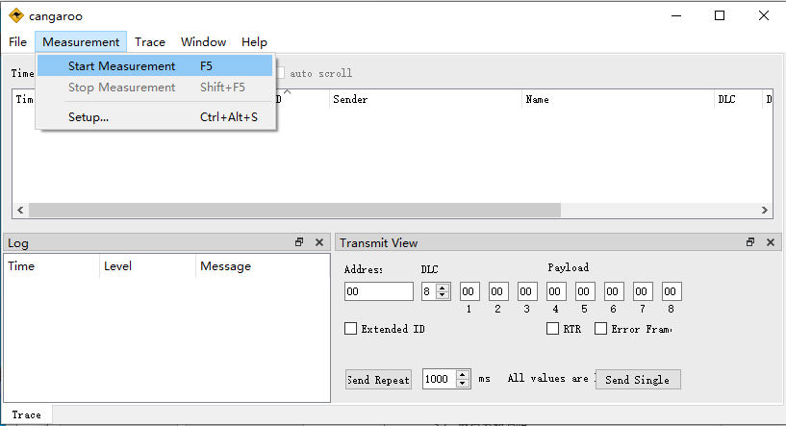
    - In the pop-up “Measurement Setup” window, click "candle0",
as shown below.
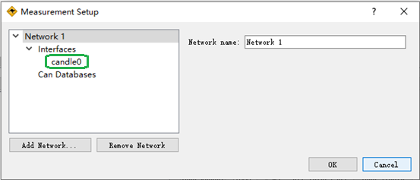

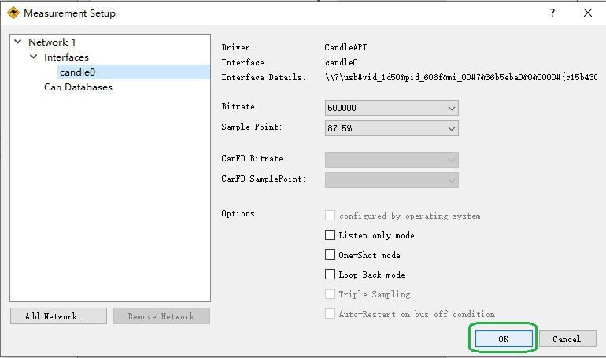
    - Use the default parameters without any modification, click "ok", as shown below.

    - The configuration is complete, as shown below.
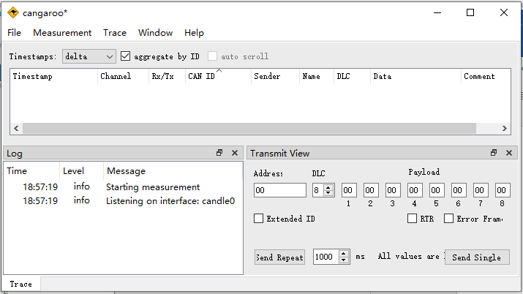

    - Select "File" -> "Save Workspace", select the save path and name, and save the configuration.

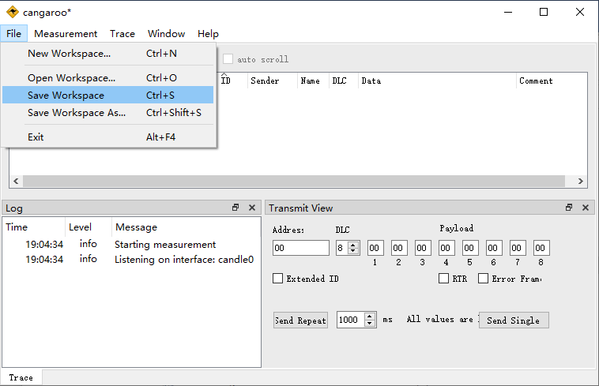

    - After the save is completed, as shown below.
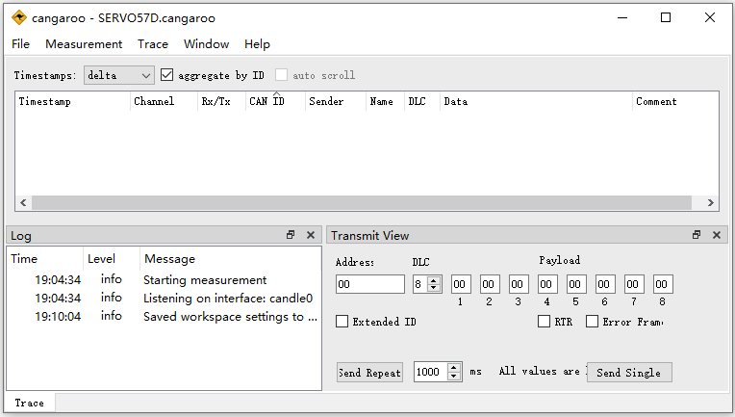

Read the encoder value
send “01 30 31”
return “01 30 00 00 00 01 29 EF 4A”
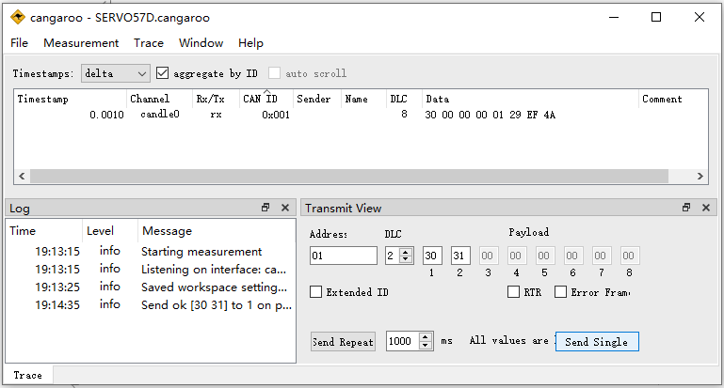

Run the motor in speed mode
Note : Please configure the working mode to 05 RS485 bus closed loop FOC mode.

    - Send 01 F6 01 40 02 3A, the motor will rotate at "speed = 600RPM, acc=2";
Return 01 F6 01 F8, the motor run in speed mode successful;
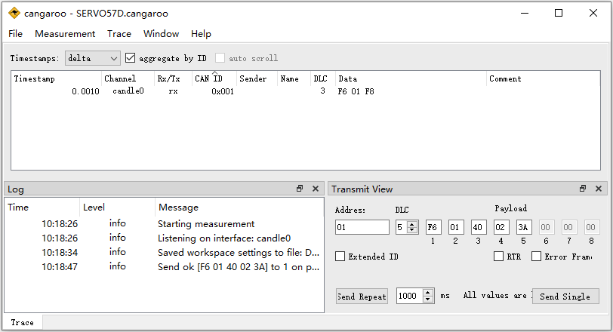

    - Send 01 FF C8 C8 to save the speed mode parameters; Return 01 FF 01 01, save successful;
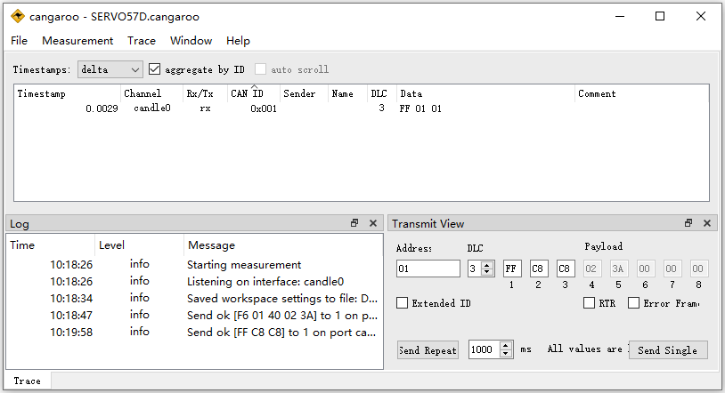

    - Send 01 F6 00 00 02 F9 to stop the motor; Return 01 F6 01 F8, the motor stops successfully;
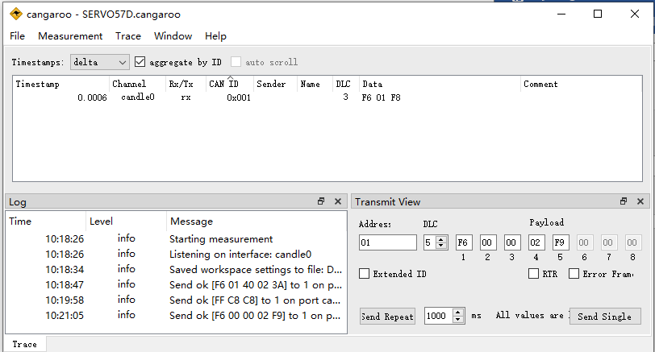

After power-on again, the motor will run according to the save speed mode parameters.

Run the motor in position mode1
Note : Please configure the working mode to 05 RS485 bus closed loop FOC mode.
    - Send 01 FD 01 40 05 09 C4 00 11, the motor will rotate forward
200 circles (16 subdivisions) with "speed = 320RPM,acc = 5"; Return 01 FD 01 FF, the motor starts to run;
Return 01 FD 02 00, the motor is run completed;
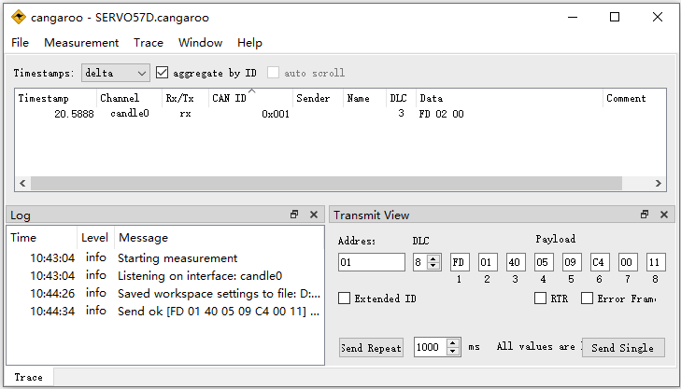

    - Send 01 FD 81 40 08 30 D4 00 CB, the motor to reverse 1000 circles with "speed = 320RPM, acc = 8" (16 subdivisions); Return 01 FD 01 FF, the motor starts to run.
Now, stop the motor by step 3.
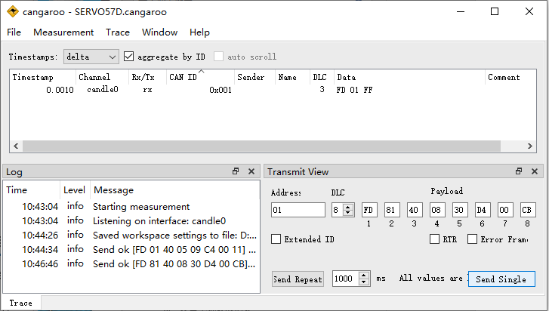

    - While the motor is running…
Send 01 FD 00 00 01 00 00 00 FF, the motor to stop with acc=1; Return 01 FD 01 FF, the motor starting to stop;
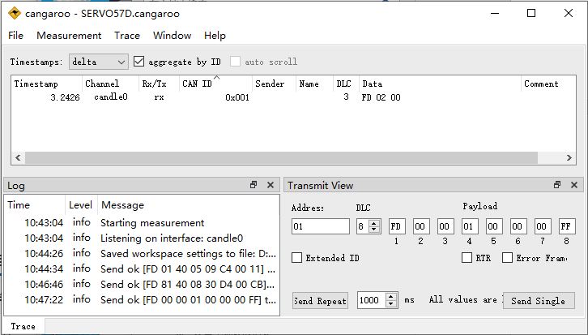
Return 01 FD 02 00, the motor has stopped

